**Lab Report No: 04**

**Name of the Experiment : File operation and permission.**

**Objective:** The file system is the most obvious aspect of any OS. This provides users the method for storage and access to data as well as programs of the operating system. In this report paper we know a lot about File operating process on Linux OS.

**Question : What is File Operation and File Permission in Linux Operating System?**

**Answer**: As you know that files are used to store the required information for its later uses.Just likelyin Linux operating system, everything is organized in the form of files and directories. By setting permissions on files and directories, one can make sure that only authorized users are allowed to access a specific data. Each file in Linux is owned by a user and group. The user is the one who creates the file and group is the one to which the user belongs to.

Understand file permission

File permissions consist of three permissions that you can apply to files and directories. In this section, you’ll learn how the system works and how to modify these permissions. Before doing this, let’s have a look at how to read the current permissions. The best method to do so is by using ls-l which will show you a list of all files and directories in the current directory.

the first column shows the file permissions.

the third column shows the user owner of the file.

the fourth column shows the group owner of the file.

**Question : Implementation of File Operation and File Permission.**

**Answer :**  Each file or directory has three basic permission types:

Read: The Read permission refers to a user’s capability to read the contents of the file.

Write: The Write permissions refer to a user’s capability to write or modify a file or directory.

Execute: The Execute permission affects a user’s capability to execute a file or view the contents of a directory.

**Implementation of File Operation**

**1.** the **ls** -command**:** It shows the contents of a particular directory – both files and directories.

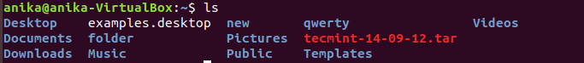

2. **ls -R command:** We can all also find child files and directories by providing the recursive option. We will provide the -R option which will list files and folders recursively.

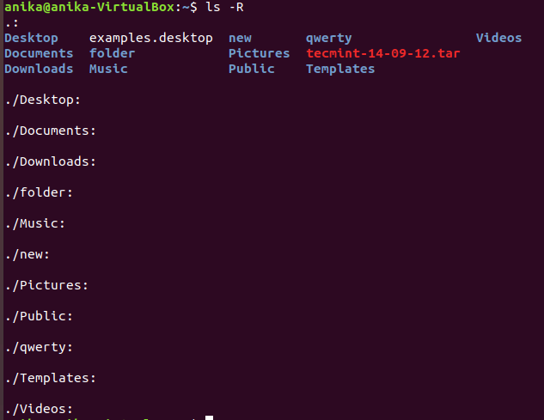

**3. ls -a command:**All operating systems have hidden files to hide them from use. It is not a security-related feature. It related to operation and reliability. We can see that files and folders like .cpan, .npm, .config etc. are listed with the help of -a option.

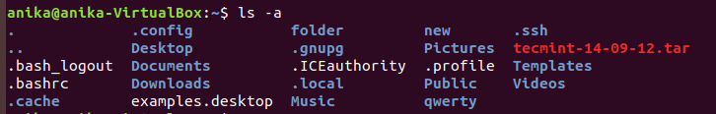

**4. cd command:** Change to directory . Here after changing directory I go to Documents directory

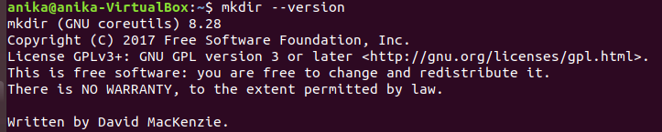

**5.mkdir** command : mkdir command in Linux allows the user to create directories. Here I create the khalid directory.



6. **rmdir** command: rmdir command is used remove empty directories from the filesystem in Linux. The rmdir command removes each and every directory specified in the command line only if these directories are empty . Here I first create a directory hello and then I remove that file by using rmdir.

7. **pwd command:** We can get the current working directory with pwd command.

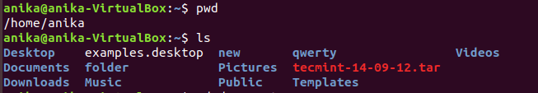

**Implementation of File permission**

**ls -l command**

One can view the permissions by checking the file or directory permissions i your favorite GUI File Manager or by reviewing the output of the “ls -l” command while in the terminal and while working in the directory which contains the file or folder.

The permission in the command line is displayed as: _rwxrwxrwx 1 owner:group

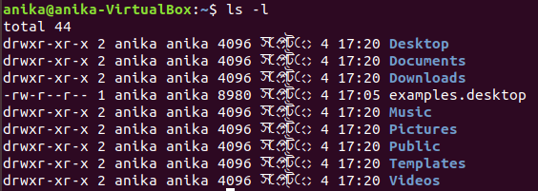

**ls The Permission Groups used are:**

u – Owner

g – Group

o – Others

a – All users

The potential Assignment Operators are + (plus) and – (minus); these are used to tell the system whether to add or remove the specific permissions.

**The Permission Types that are used are:**

* r – Read
* w – Write
* x – Execute

So for an example, lets say I have a file named file1 that currently has the permissions set to _rw_rw_rw, which means that the owner, group and all users have read and write permission. Now we want to remove the read and write permissions from the all users group.

To make this modification you would invoke the command: chmod a-rw file1  
To add the permissions above you would invoke the command: chmod a+rw file1

**-al command:** command to view all files in a list:

**Conclusion:** File Management. Some operating systems offer access to hardware through file management. Linux, which is part of Android OS is an example. So in Android, you can't make anything useful without it. It's also possible to make an operating system without files. It's valid to treat a disk as if it is just a big